COT 3 .AT 1
CSA1606-DWDM
Name: P.Sudharshan Reddy
Reg No: 192372204

Activity 3: Weather Analysis System
Problem Statement
Analyze weather conditions over one year.
Task
Create a workflow that:
• Imports weather data.
• Calculates average temperature and rainfall.
• Detects extreme weather events.
• Visualizes monthly trends.

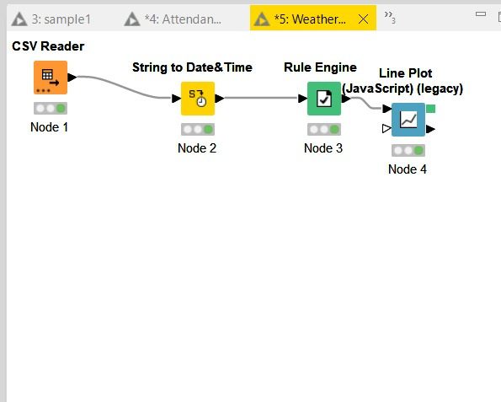
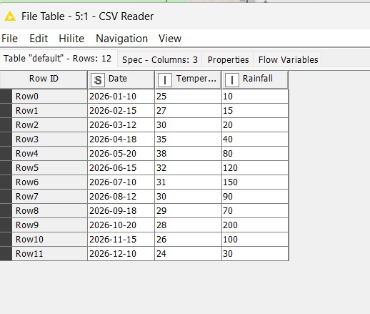
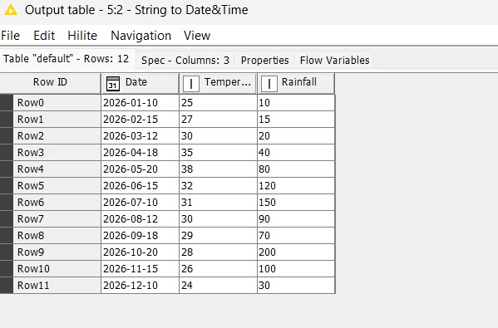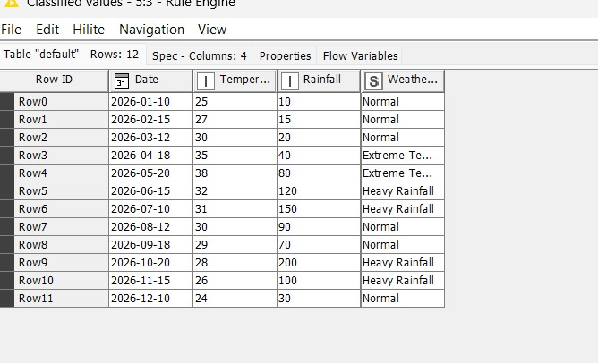
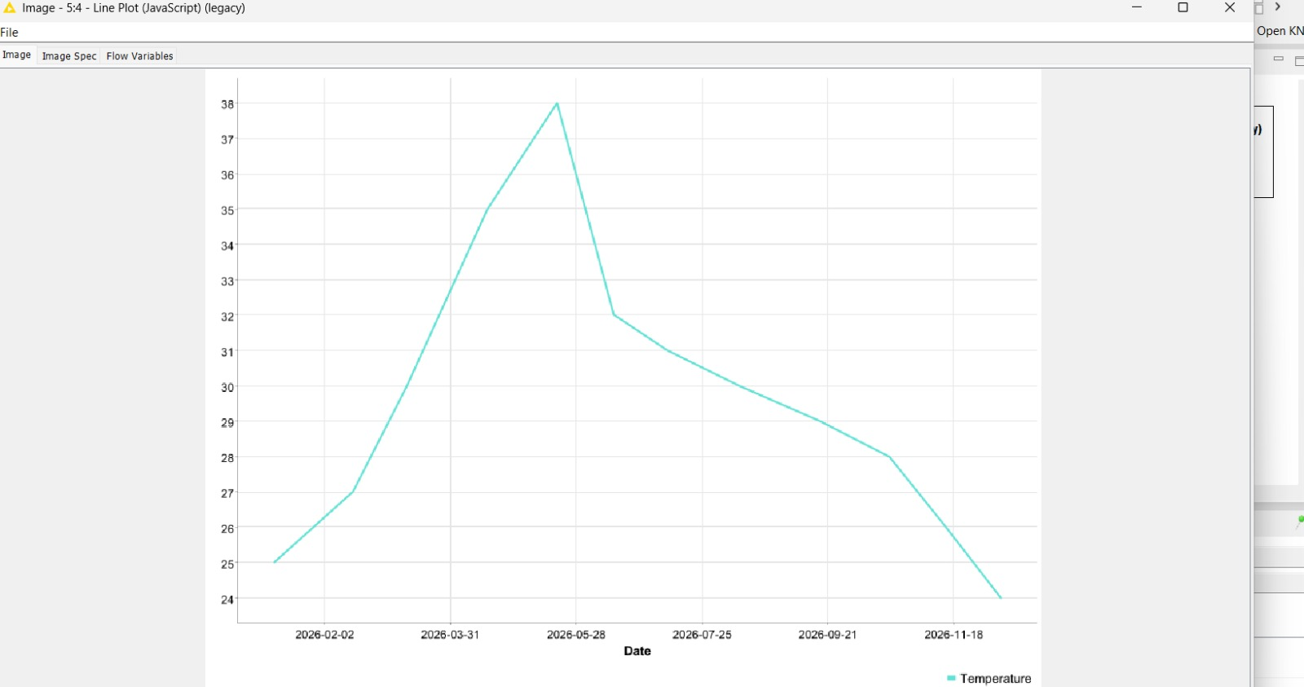
Activity 10: Attendance Monitoring System
Problem Statement
Analyze attendance records to identify students with low attendance.
Task
Build a workflow that:
• Imports attendance data.
• Calculates attendance percentages.
• Flags students below the attendance threshold.
• Generates a report.

